**Make unlimited updates from one place**

With Listing Sync, you have the power to manage all of of your business information from a single dashboard. Give your customers the guarantee they will always see the most up-to-date information when they search for your business.

**Generate and fix business listings with one click**

Build a presence on an established network of over 70 search engines, social networks, business directories, and more!

**Protect listings from changes by third parties**

Competitors, data aggregators, and other third parties can manipulate your business listings without warning. Listing Sync gives you peace of mind by automatically re-establishing the accurate data if anything changes.

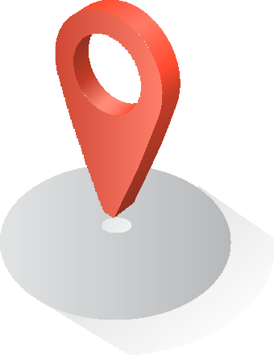

**LISTING SYNC**

Online Business Listing Management

**Get accurate, get found.**

Accurate business listings help search engines and consumers find local businesses online. The problem is that you don’t have the time to create and maintain dozens of business listings.

Listing Sync gives you one place to create and sustain accurate business listings across an established network of listing sites.

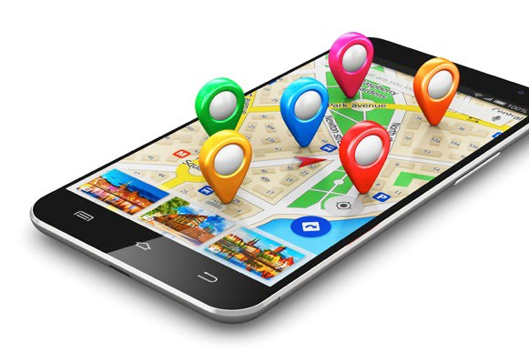

**Why do you need accurate listings?**

Consumers depend on accurate listings when searching for a local businesses online. Incorrect business listings lead to lost sales opportunities, frustrated consumers, and weakened search rankings. In fact, 73% of consumers stated that they lose trust in a brand when an online listing shows incorrect information. Therefore, accurate listings are considered to be an essential component of the local marketing stack.

**Sync to Google, Facebook, and Twitter for no extra charge**

You read that correctly—with Listing Sync, you can instantaneously update your business listing info on these three online powerhouses for no additional fee.

**Listing Sync allows you to take control of your business listings and protect your brand online.**

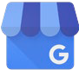

**LISTING SYNC**

Online Business Listing Management

***80% of consumers use search engines to find local information like business address, hours and directions.***

***local searches lead 50% of mobile visitors to visit the business they searched in less than 24 hours***

**Name**

Position

Company Office Phone: Cell Phone: Linked In:

Email | Website

insert photo here