**How customers find your listing Where customers find you on Google**

**What customers do once they find your listing**

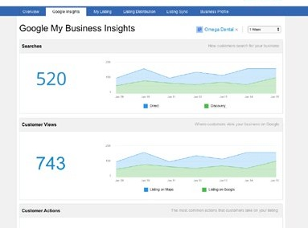

**LISTING BUILDER**

The most comprehensive business listing solution for local businesses.

**Get found. Gain traffic. Grow revenue.**

Establish accurate business listings and **appear in more places across the web**. Packed with three powerful presence management tools—Google Insights, Listing Sync and My Listing—Listing Builder is **the most comprehensive business listing solution on the market**.

**Google Insights**

Understand how your **business is performing on Google Search and Maps**. Google Insights in Listing Builder provides a valuable glimpse into your customer’s activities, including:

**•**

**•**

**•**

**Listing Sync**

Accurate business listings help search engines and consumers find local businesses online. Listing Sync gives you **one place to create and sustain accurate business** listings across an established network of over 25 listing sites. With Listing Sync you can:

* Sync to Google, Facebook, and Twitter for no extra charge.
* Generate and fix business listings with one click.
* Make unlimited updates from one place.
* Protect listings from changes by third parties.



**Why do you need accurate listings?**

Consumers depend on accurate listings when searching for a local businesses online. Incorrect business listings lead to lost sales opportunities, frustrated consumers, and weakened search rankings. In fact, 73% of consumers

stated that they lose trust in a brand when an online listing shows incorrect information. Therefore, accurate listings are considered to be an essential component of the local marketing stack.

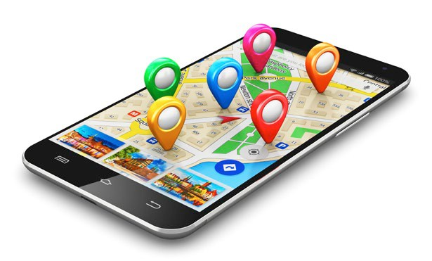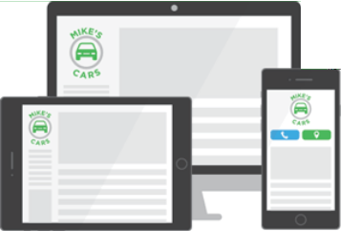

**LISTING BUILDER**

The most comprehensive business listing solution for local businesses.

**Keep Your Business Listings Up-to-Date**

Whenever you make changes to your business info within our platform—including hours of operation and website—we’ll automatically sync this info to all of your business listings.

***local searches lead 50% of mobile visitors to visit the business they searched in less than 24 hours***

***4/5 consumers use search engines to find local information like business address, hours and directions.***

**Name**

Position

Company Office Phone: Cell Phone: Linked In:

Email | Website

insert photo here

**My Listing**

With My Listing, you can **easily create a mobile-responsive business listing that is optimized for local search**. This customizable listing allows you to:

* Drive more traffic to your website.
* Display your store hours and contact info (so it’ll be easier for people to find your business).
* Design and share coupons to generate new revenue.