**Hands-Free Reputation Management**

Put our Digital Agency to work on your local reputation today. We’ll increase your visibility, post regularly to fans and followers, respond to negative reviews and socialize the positive ones. Plus, we’re always just a phone call away.

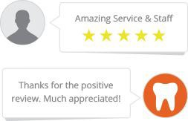

**FULL-SERVICE**

**DIGITAL AGENCY**

**3**

**Engage Negative Reviews...**

and convert disgruntled reviewers into fans. You can’t please everyone, but we’ll suggest an appropriate response and give you a second chance.

**Share Positive2**

**Reviews...**

in order to build trust in your online community and spread your success stories throughout your social channels.

**Maximize Visibility... 1**

through accurate listings on all of your relevant

online directories. We’ll will correct inconsistent listings and create accounts on your behalf so you can update them later.

**Call today and take advantage of our Full-Service Digital Agency**

**Receive**

**Comprehensive**

**Reports...**summarizing all completed tasks,  
including visibility, reviews,  
and mentions.

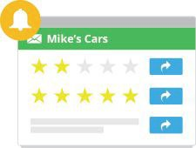

**FULL-SERVICE**

**DIGITAL AGENCY**

Hands-free Reputation Management

**Name**

Position

Company Office Phone: Cell Phone: Linked In:

Email | Website

insert photo here

**Access Phone and  
Email Support... 6**  
so that all questions and concerns   
can be addressed as quickly   
as possible.

**Update Social Posts Regularly...**

to fans and followers on social media accounts, including Facebook and Twitter to help increase your audience.